Final Advanced Java Project



ABSTRACT-USERGUIDE &

TECHNICAL SPECIFICATION

-Faisal Khan Imtiyaz

[Msc (SE)]

QUIZ MANAGER

**Table of Contents**

1. Subject Description

2. Subject Analysis

2.1 Major Features

2.2 Application feasibility

2.3 Objectives and concentrations

2.4 Scope of the application

2.5 UML Scope

2.6 Technology

2.7 User Interface

3. Screenshots

4. Bibliography

1. **Subject Description:**

The goal of this project is to develop a program that helps in dealing with quiz assessments. This document will propose all features and technical specification of the project. It contains details about objectives, scope limitation, primary requirements, possible project risks, database design, and application flow.

The usual problem while preparing an evaluation, are to:

* Constitute an appropriate evaluation regarding of the required level.
* Reuse former questions.
* Organize sample evaluations.
* Correct automatically the MCQ questions.

The implementation of this project has been done by using Frontend (HTML, Angular JS), Backend (REST, Java 8), Database (H2), Business Logic Framework (Hibernate, Spring) and Server (Tomcat).

1. **Subject Analysis:**

**2.1.Major Features:**

* Authentication: A user should have a valid login in-order to go into the application.
* Admin: Can be able to create the quiz questions and review the scores.
* Student: Can be able to take the test and view scores.

**2.2.Application Feasibility:**

* The application is developed with Java, Springs and hibernate. The SQL calls are dynamically called by using H2 Data Base connection for database.
* We have used Java, Spring MVC, Boot, ORM and Hibernate in the backend and JSP pages in the front-end.

**2.3. Objectives and concentrations:**

This Quiz Management Application handles 2 Identities:

* Student
* Admin

**Students**: Students are having privilege to create the account, choose the relevant quiz type and quiz name, attend the quiz, view the result at the same time.

**Admin**: Admin on the other hand is able to create his/her account, edit/delete/view the registered student’s details with their quiz score. Apart, from managing the student’s details they are able to create the quiz specifying name, and type.

**2.4. Scope of the Application:**

* The system handles all the operations, and generates reports as soon as the test is finish, that includes name, mark, time spent to solve the exam.
* Allow students to see or display his answers after the exam is finish.
* The type of questions is only multiple choice right.
* Manage the students, the admin/professors can add/edit/delete student and review their scores.

Our objectives are in writing and executing the tests

* We want to code and run the tests without leaving the IDE (Eclipse).
* There should be no special deployment of the code required

**2.5. UML Scope:**

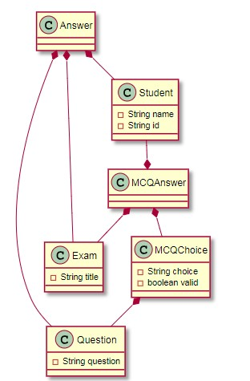

**2.6. Technology :**The implementation of this project has been done by using Frontend (HTML, CSS, JSP, JavaScript), Backend (Java 8), H2 (Data Base), Business Logic Framework (Hibernate, Spring ORM, Spring Boot, Spring MVC) and Server (Tomcat 9).

**2.7. User Interface:**

Application will be accessed through a Browser Interface. The interface would be viewed best using 1024 x 768 and 800 x 600 pixels resolution setting. The software would be fully compatible with Microsoft Internet Explorer for version 6 and above. No user would be able to access any part of the application without logging on to the system.

1. **Screenshot:**

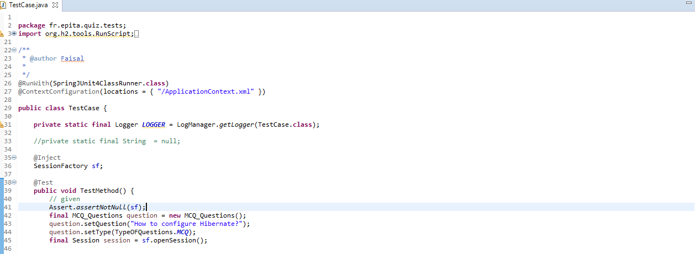

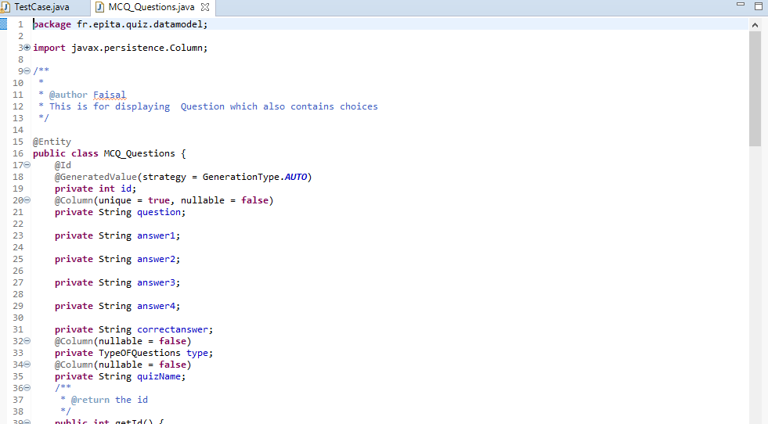

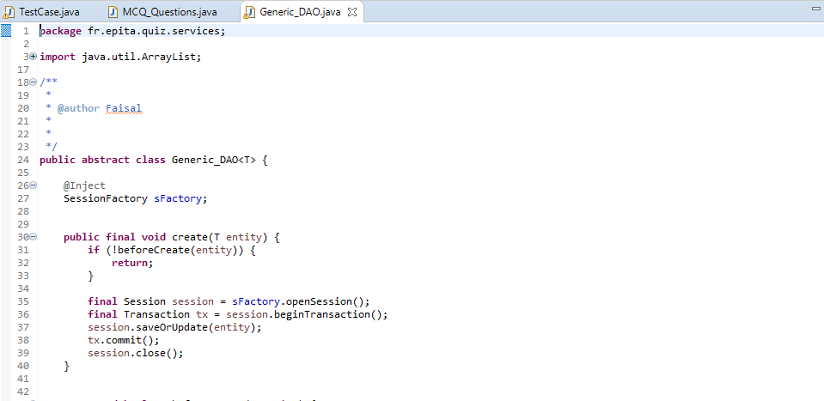

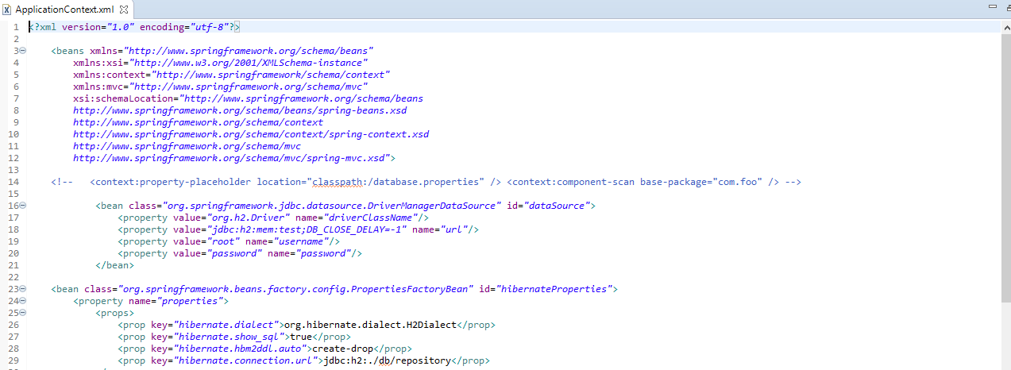

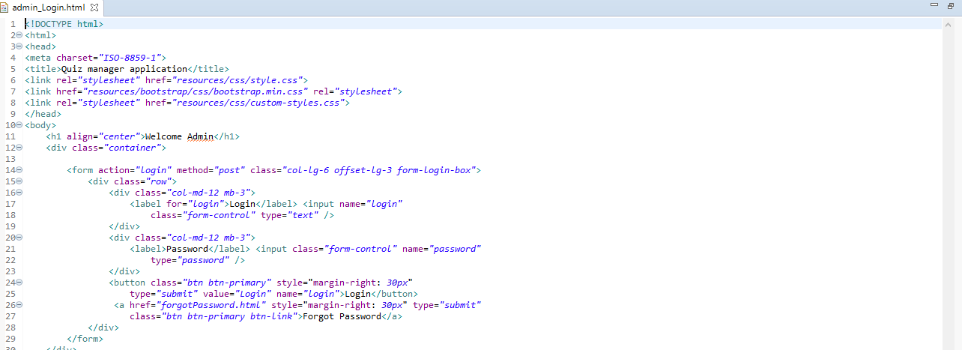

**4.Bibliography:**

* [**https://github.com/thomasbroussard**](https://github.com/thomasbroussard)
* **https://thomas-broussard.fr/work/java/courses/project/advanced.xhtml**